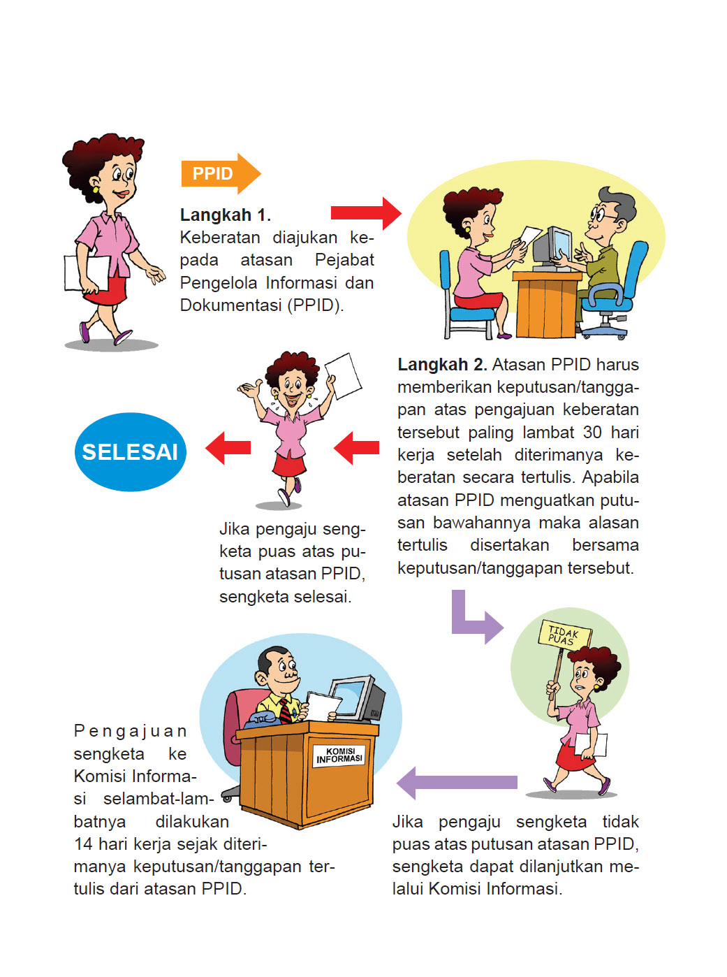
TATA CARA PENGAJUAN KEBERATAN ATAS PERMOHONAN INFORMASI

PEMERINTAH KOTA MAGELANG
PEJABAT PENGELOLA INFORMASI DAN DOKUMENTASI
JL. PAHLAWAN NO.74 TELP. (0293), 362553 Magelang 56117
Email : ppid@magelangkota.go.id

PERNYATAAN KEBERATAN ATAS PERMOHONAN INFORMASI

- INFORMASI PENGAJU KEBERATAN
Nomor Registrasi Keberatan :..................................................
Nomor Pendaftaran Permohonan Informasi :..................................................
Tujuan Penggunaan Informasi :.............................................................................................................
..............................................................................................................
..............................................................................................................
Identitas Pemohon :.................................................. ..........................................................
Nama :.................................................. ..........................................................
Alamat :.................................................. ..........................................................
.............................................................................................................
Pekerjaan :.................................................. ..........................................................
Nomor Telepon :.................................................. ..........................................................
Identitas Kuasa Pemohon :.................................................. ..........................................................
Nama :.................................................. ..........................................................
Alamat :.................................................. ..........................................................
:.................................................. ..........................................................
Nomor Telepon :.................................................. ..........................................................
- ALASAN PENGAJUAN KEBERATAN*** :

Permohonan informasi ditolak
  - Informasi berkala tidak disediakan
  - Permintaan Informasi tidak ditanggapi
  - Permintaan Informasi ditanggapi tidak seperti yang diminta
  - Permintaan informasi tidak dipenuhi
  - Biaya yang dikenakan tidak wajar
  - informasi disampaikan melebihi batas waktu yang ditentukan
- KASUS POSISI (tambahkan kertas bila perlu)

.............................................................................................................................................................................................
.............................................................................................................................................................................................
.............................................................................................................................................................................................
D. HARI/TANGGAL TANGGAPAN ATAS KEBERATAN AKAN DIBERIKAN : .............................................................

Demikian keberatan ini saya sampaikan, atas perhatian dan tanggapannya saya ucapkan terima kasih.

Magelang,...............................

Petugas Informasi (Penerima Keberatan)

(.............................................)

Pengaju Keberatan

(...............................................)

